Supplementary material for

Transport of cationic liposomes in a human Blood Brain Barrier model: role of the stereochemistry of the gemini amphiphile on liposome biological features

Beatrice Simonis^{a, b,≠}, Domenico Vignone^{c,≠}, Odalys Gonzalez Paz^{c}, Enrica Donati^{d}, Maria Laura Falchetti^{e}, Cecilia Bombelli^{b}, Antonella Cellucci^{c}, Giulio Auciello^{c}, Ivan Fini^{c}, Luciano Galantiniª, Rudaba Zaman Raya Syedaª, Marco Mazzonna^{d}, Maria Patrizia Mongiardi^{e}, Francesco Buonocore^{f}, Francesca Ceccacci^{b*}, Annalise Di Marco^{c**}, Giovanna Mancini^{d}
ª Sapienza Università di Roma, Dipartimento di Chimica, P.le A. Moro 5, Rome, Italy
^{b} CNR-ISB, Istituto per i Sistemi Biologici, Sede Secondaria di Roma-Meccanismi di Reazione c/o Dipartimento di Chimica, Sapienza Università di Roma, P.le A. Moro 5, Rome, Italy,
^{c} High content Biology and Screening, IRBM SpA, via Pontina Km 30.6, 00071 Pomezia (RM), Italy,
^{d} CNR-ISB, Istituto per i Sistemi Biologici, Area della Ricerca di Roma 1, Strada Provinciale 35d 9, 00020 Montelibretti, Rome, Italy
^{e} CNR-IBBC, Istituto di Biochimica e Biologia Cellulare, Via E. Ramarini, 32, 00015 Monterotondo
Scalo, Rome, Italy
^{f} Dipartimento per la Innovazione nei sistemi biologici, agroalimentari e forestali, Università della Tuscia (DIBAF), Largo dell'Università snc, 01100 Viterbo, Italy
≠The authors contributed equally to the work

*corresponding author at: francesca.ceccacci@cnr.it, CNR-Institute for Biological Systems (ISB) secondary office of Rome-Reaction Mechanisms c/o Department of Chemistry, Sapienza University, P.le A. Moro 5, 00185 Roma Italy. Phone: +39 0649913078; fax: +39 0649913629
**corresponding author at: A.DiMarco@irbm.com, High content Biology and Screening, IRBM SpA, via Pontina Km 30.6, 00071 Pomezia (RM), Italy. Phone +39 0691093692; fax +39 0691093654

Index
Determination of liposome composition page 2
Cell viability assay of HUVEC and BJ cells exposed to DPPC/CHOL/SS/PA-PEG3-mannose formulation page 7
Confocal microscopy of HUVEC cells exposed to fluorescently-labelled DPPC/CHOL/SS/PA-PEG3-mannose formulation page 8
Haemolytic assays pag 10

Determination of liposome composition
The concentration of the components in F1b-F5b formulation was quantified by ¹H NMR analysis; NMR spectra were recorded at 27 °C on a Bruker AVANCE 600 NMR spectrometer operating at the proton frequency of 600.13 MHz.
General procedure: 1 mL of the liposome solution was freeze dried and the residues was solubilized in 1 mL of CDCl₃. An internal standard was added (4-methylacetophenone, [1mM] final concentration in the sample) and the solution was filtered to remove inorganic salts present in the HBSS-HEPES buffer. 4-Methylacetophenone was chosen as internal standard since it provides well-separated signals without any interference with the signals of the liposome constituents in the NMR spectra. In particular, for quantitative purposes, the multiplet signal at 7.796-7.776 ppm (Figure S1) of 4-methylacetophenone was selected as reference signal because it did not overlap with the other signals.
The signals used for quantification of lipid components in F1b-F5b formulations were identified by comparison with reference samples of the constituents alone in CDCl₃. The signals chosen to quantify the liposome constituents were: the multiplet signal at 5.216-5.180 ppm (1H) for DPPC (Figure S2), the singlet signal at 0.678 ppm (3H) for CHOL (Figure S3), the multiplet signal at 4.507-4.497 ppm (2H) for SS (Figure S4), the multiplet signal at 4.206-4.186 ppm (2H) for mPEG-DSPE (Figure S5), the doublet signal 4.522 ppm (2H, J = 9.455 Hz) for MESO and the singlet signal at 7.870 ppm (1H) for PA-PEG3-mannose. Results of the analysis evidenced that the concentrations of the components were in good agreement with those expected (with an approximate deviation of 3-6%).
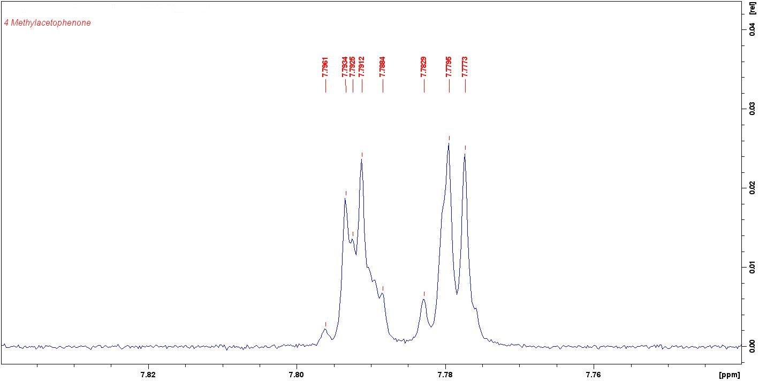Figure S1. Reference signal at 7.796-7.776 ppm for 4-methylacetophenone.

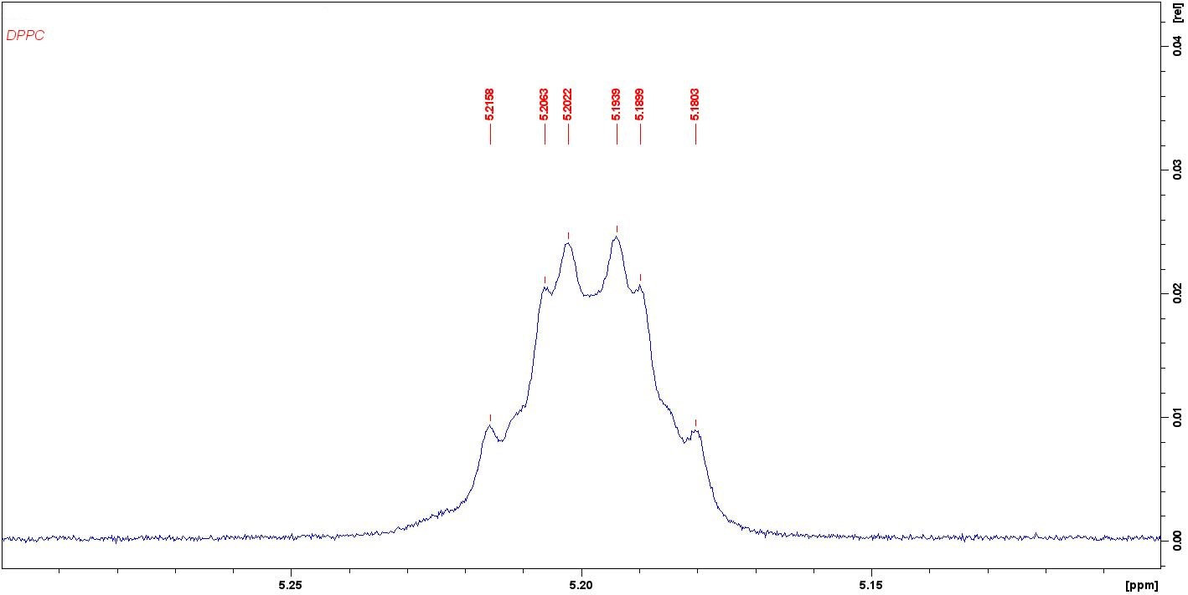Figure S2 Reference multiplet signal at 5.216-5.180 ppm (1H) for DPPC.

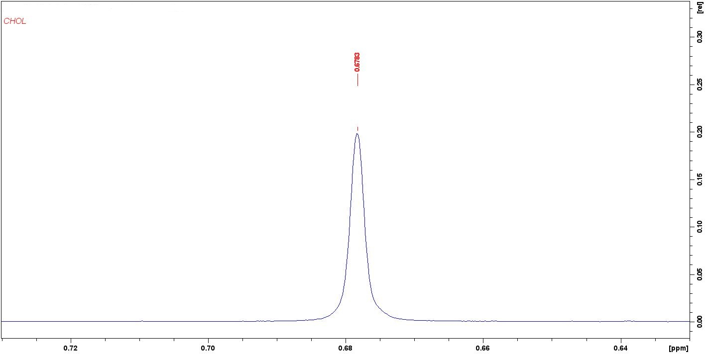
Figure S3. Reference signal at 0.678 ppm (3H) for CHOL

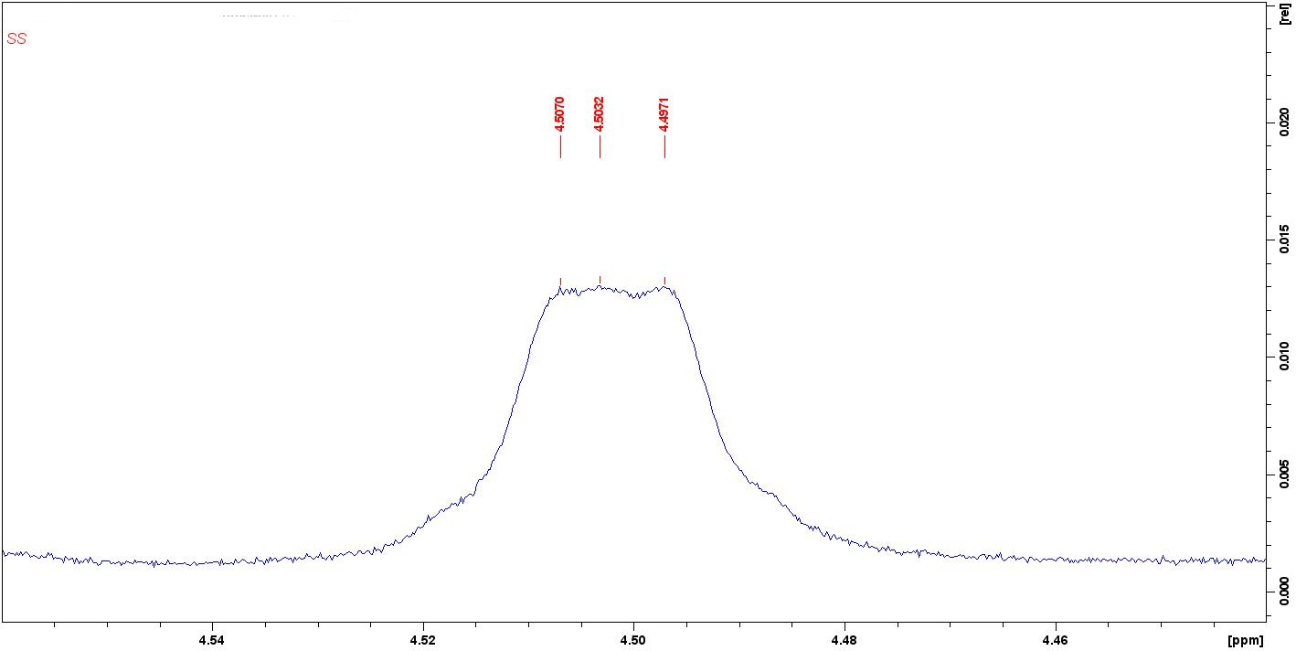
Figure S4. Reference signal at 4.507-4.497 ppm (2H) for SS.

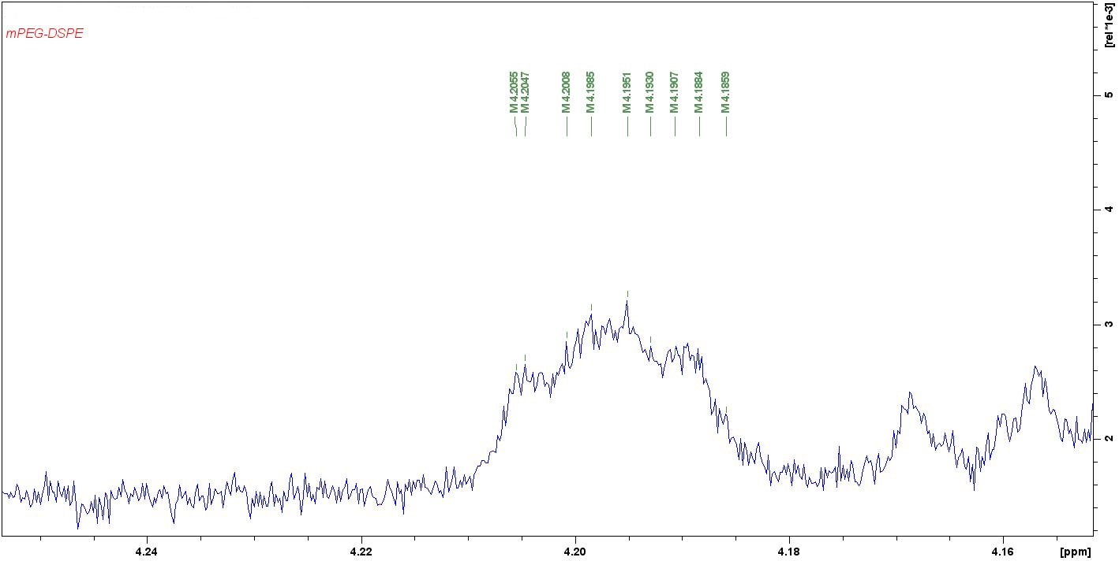Figure S5. Reference multiplet signal at 4.206-4.186 ppm (2H) for mPEG-DSPE.

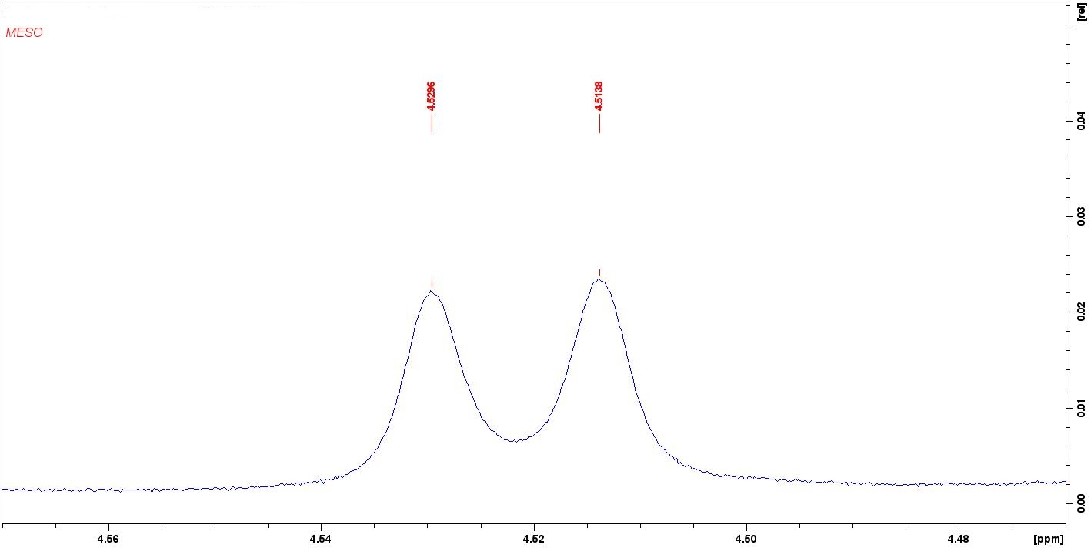Figure S6. Reference doublet signal at 4.522 ppm (2H) for MESO.
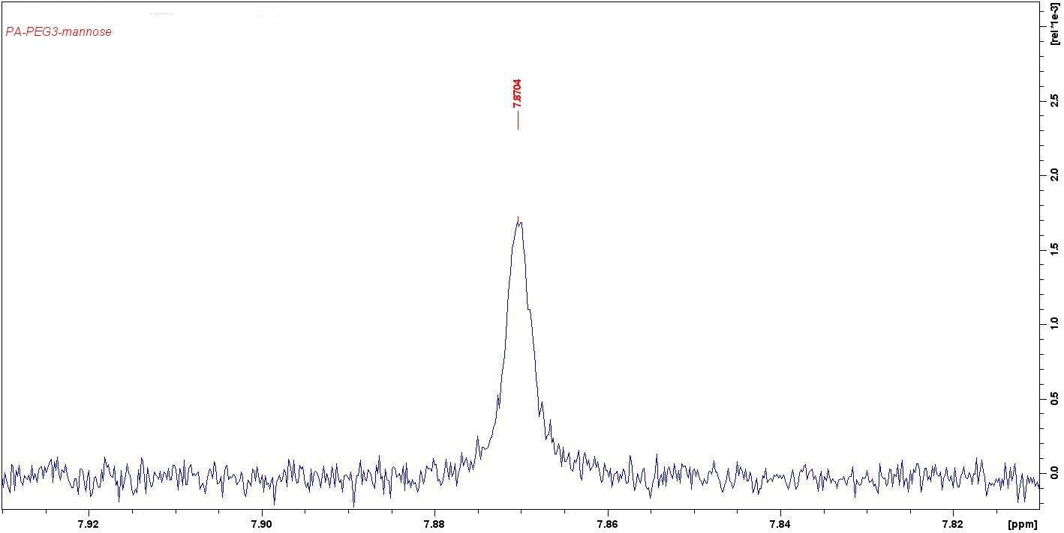
Figure S7. Reference singlet signal at7.870 ppm (1H) for PA-PEG3-mannose.

Cell viability assay of HUVEC and BJ cells exposed to DPPC/CHOL/SS/PA-PEG3-mannose formulation

Figure S8. Cell viability assay of HUVEC and BJ cells exposed to DPPC/CHOL/SS/PA-PEG3-mannose formulation. Cells were exposed to liposomes for 6 hours and cell viability was addressed by MTS assay 48 (left panel) and 72 hours (right panel) following liposome withdrawal. n = 3 biological replicates.

Confocal microscopy of HUVEC cells exposed to fluorescently-labelled DPPC/CHOL/SS/PA-PEG3-mannose formulation

Figure S9. Confocal microscopy of BJ (A) and HUVEC (B) cells exposed to rhodamine-labelled DPPC/CHOL/SS/PA-PEG3-mannose formulation. The presence of NBD-PE-labelled F5a liposomes (green) is visible at the inner surface of BJ cells (arrows). BJ cytoscheleton was stained by an anti-α tubulin antibody, revealed by an Alexa Fluor 555 secondary antibody (red). Nucleus was stained by DAPI (blue) (A). The presence of rhodamine-labelled liposomes (red) is visible at the inner surface of HUVEC cells (arrows). HUVEC cytoscheleton was stained by an anti-α tubulin antibody, revealed by an Alexa Fluor 488 secondary antibody (green). Nucleus was stained by DAPI (blue) (B). Magnification 40 x, scale bar 10 µm.
Haemolytic activity assay
The haemolytic assay was performed on rabbit erythrocytes (Rockland) maintained in Alsever’s solution (Innovative Research). Briefly, after the removal of Alsever’s solution, the erythrocytes were resuspended in PBS and counted in a hemocytometer^{1,2}. A suspension of about 5,000,000 red blood cells was incubated with four concentrations (5 µM, 10 µM, 50 µM, 250 µM) of the five liposome formulations (by appropriate dilution in PBS of the 5 mM formulations to 100 µL final volume) in a 96-well microplate. As a negative control, erythrocytes were incubated without the liposomes, while as a positive control, erythrocytes were added with triton 10% v/v. The plate was incubated at 37 °C for 2 h and subsequently centrifuged at 1200 rpm for 3 min to separate the pellet from the supernatant. The absorbance of the supernatant was measured at 492 nm. Each point was made in quadruplicate. The relative OD compared to the positive control defined the percentage of haemolysis. Statistical analysis was performed using two-way ANOVA analysis followed by Bonferroni’s post-test.
Figure S10. % of haemolysis of the five different liposome formulations. All the differences in relation to the positive control were statistically significant.

The explored concentration ranged from 5 µM to 250 µM total lipid concentration which corresponds to a range from 0.003 mg/mL to 0.15 mg/mL.³

1. Belokoneva, O.S.; Villegas, E.; Corzo, G.; Dai, L.; Nakajima, T. The hemolytic activity of six arachnid cationic peptides is affected by the phosphatidylcholine-to-sphingomyelin ratio in lipid bilayers. Biochim. Biophys. Acta 2003, 1617, 22–30.
2. F. Bugli, F. Massaro, F. Buonocore, P.R. Saraceni, S. Borocci, F. Ceccacci, C. Bombelli, M. Di Vito, R. Marchitiello, M. Mariotti, R. Torelli, M. Sanguinetti, F. Porcelli. Design and characterization of myristoylated and non-myristoylated peptides effective against Candida spp clinical isolates. Int. J. Mol. Sci. (2022), 23: 2164.
3. S. Mourtas, G.P. Michanetzis, Y.F. Missirlis, S. G. Antimisiaris. Haemolytic activity of liposomes: effect of vesicle size, lipid concentration and polyethylene glycol-lipid or arsonolipid incorporation. J. Biomed. Nanotechnol. (2009), 5(4):409-15.

